TASK ON RDS

*Create mariadb db on ec2.*

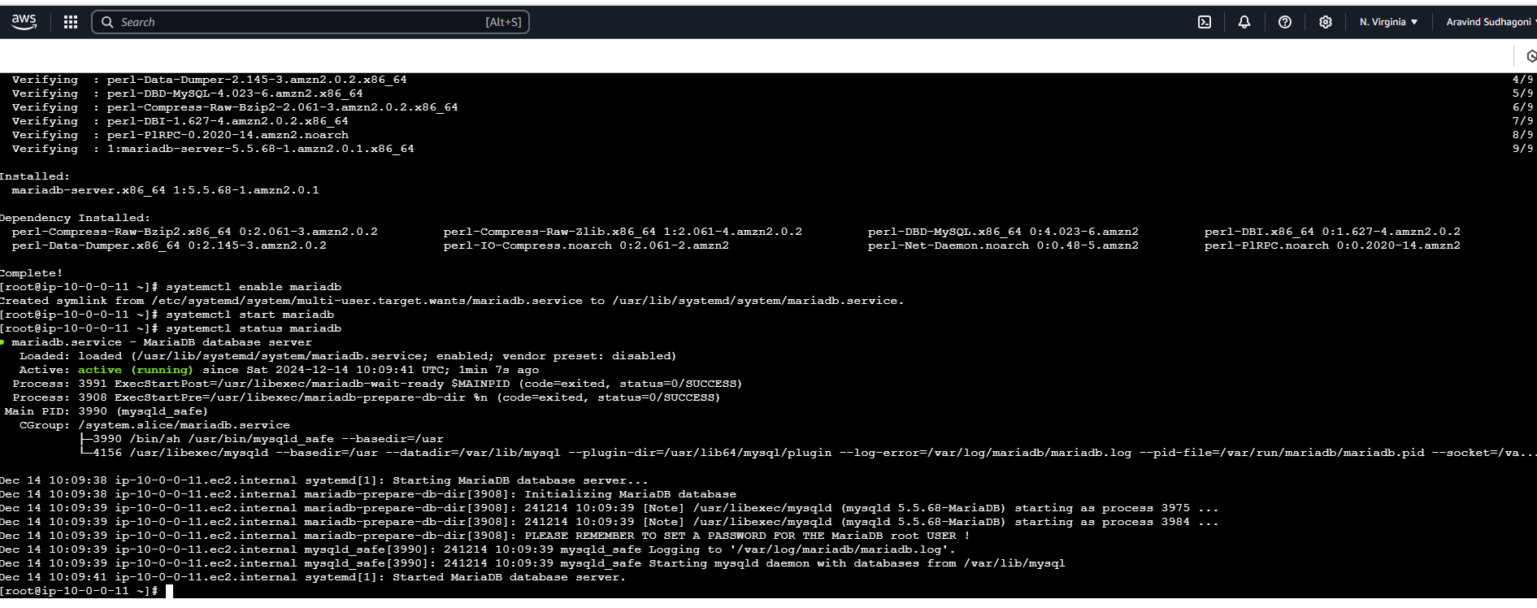

*Insert some dummy data*

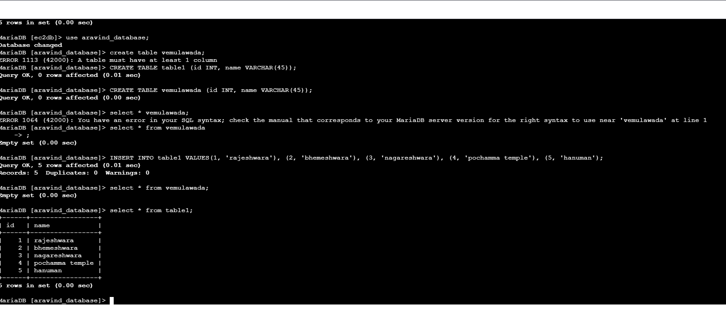

*Take the backup of dummy data on ec2*

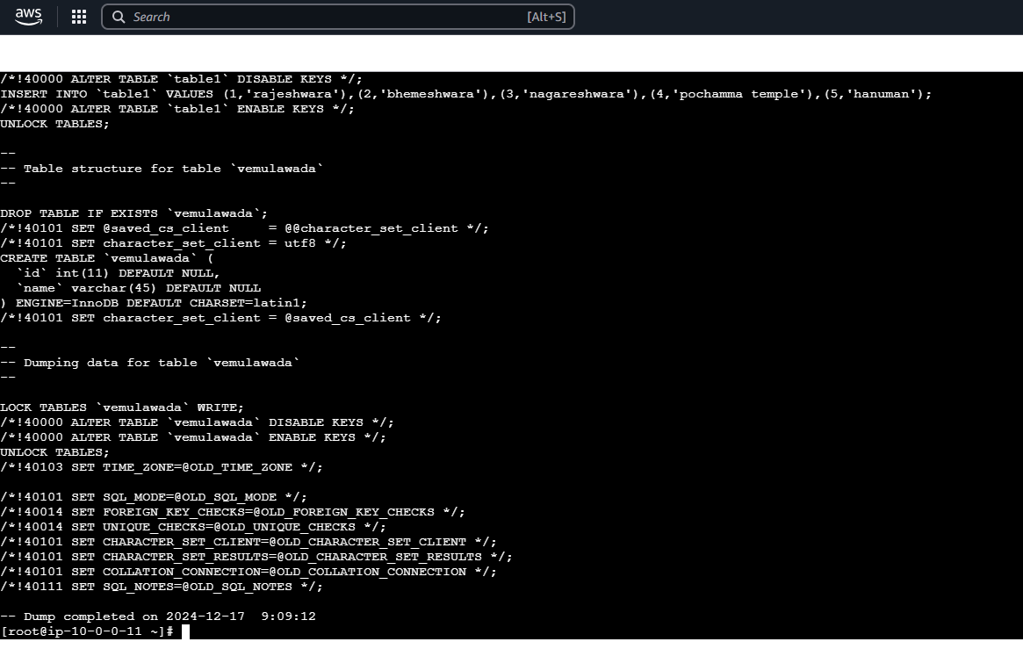

*launch Mariadb RDS instance*

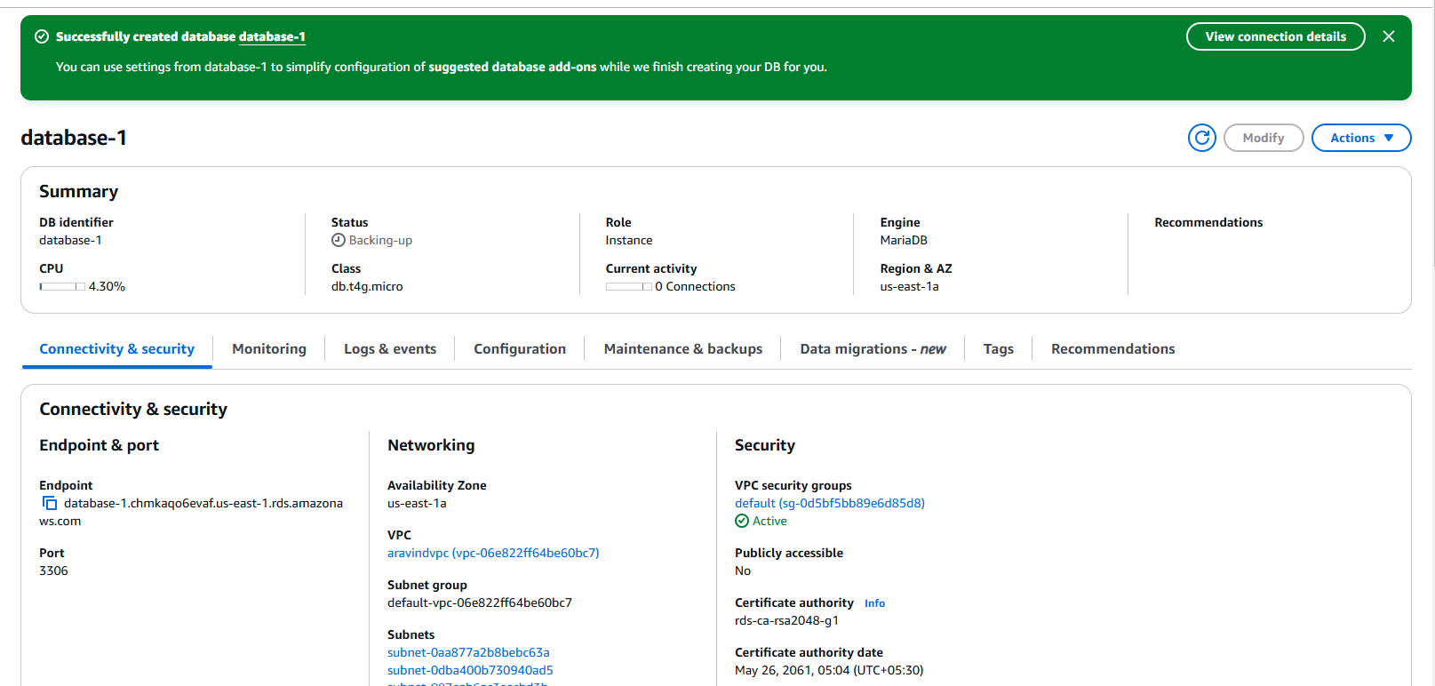

***Migrate database from ec2 to RDS***

*Install mysql db on ec2*

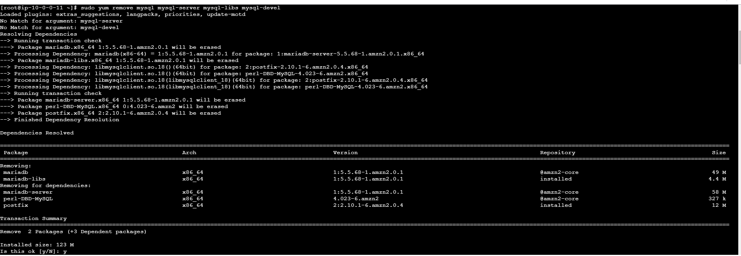

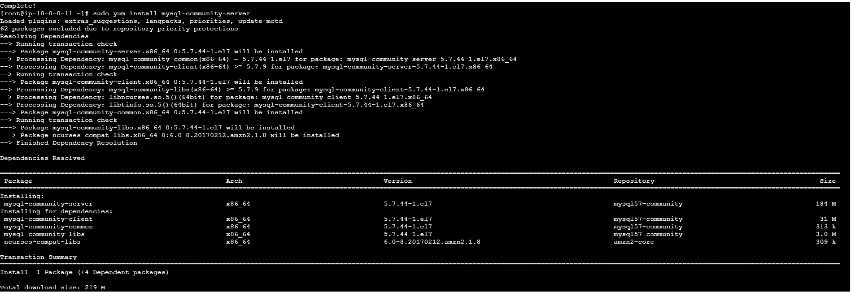

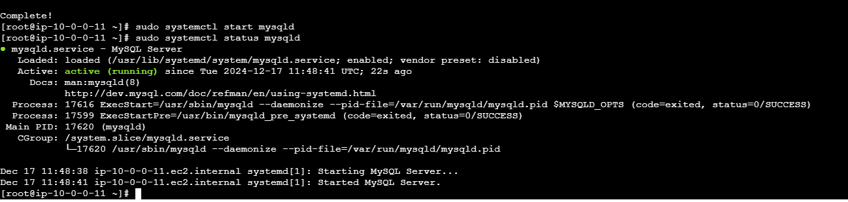

*Launch mysql RDS image*

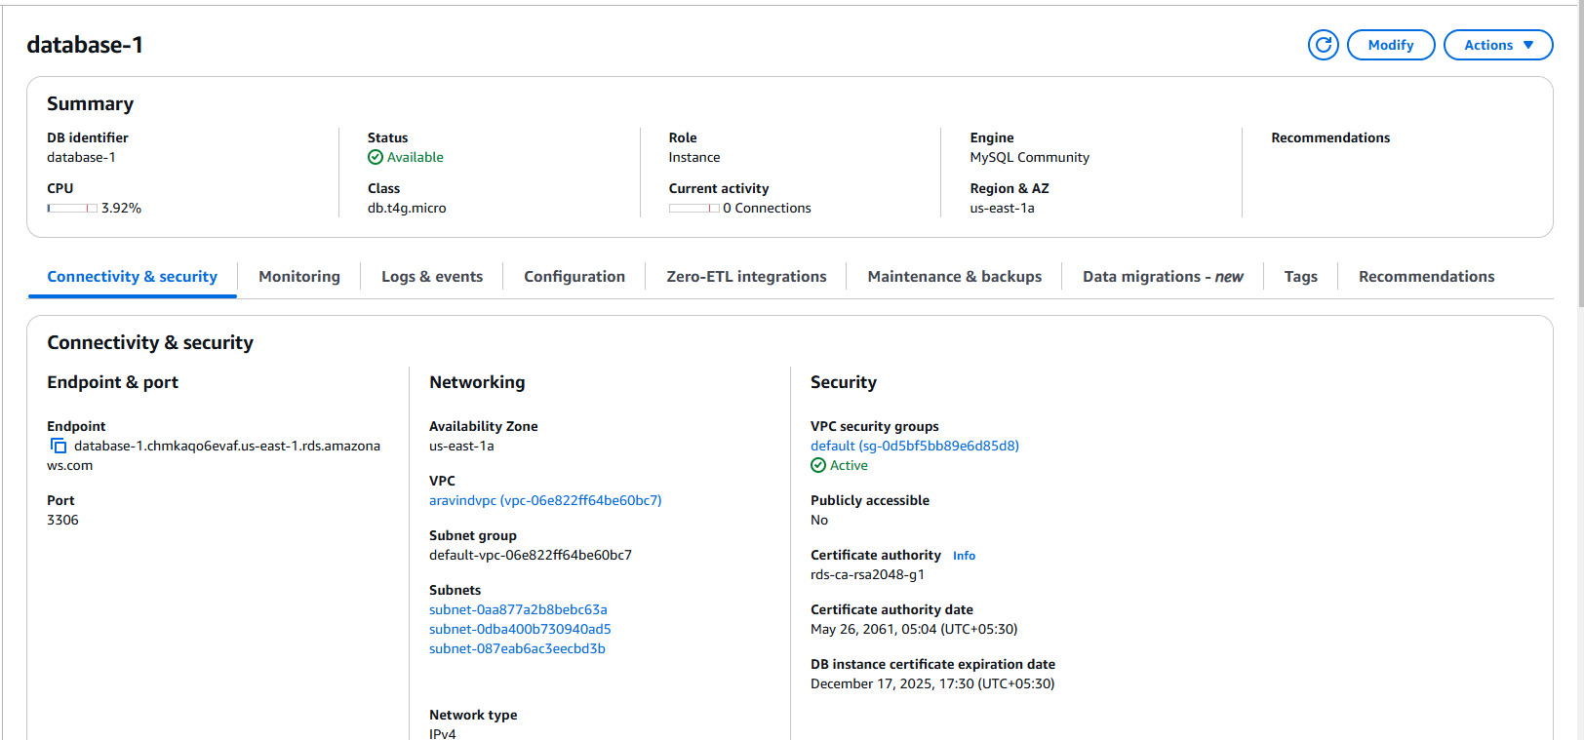

*Configure multi AZ*

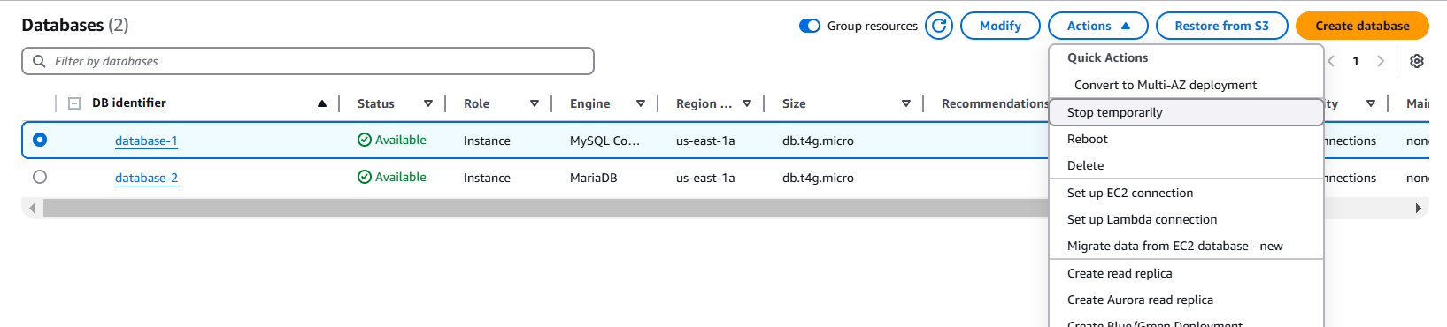

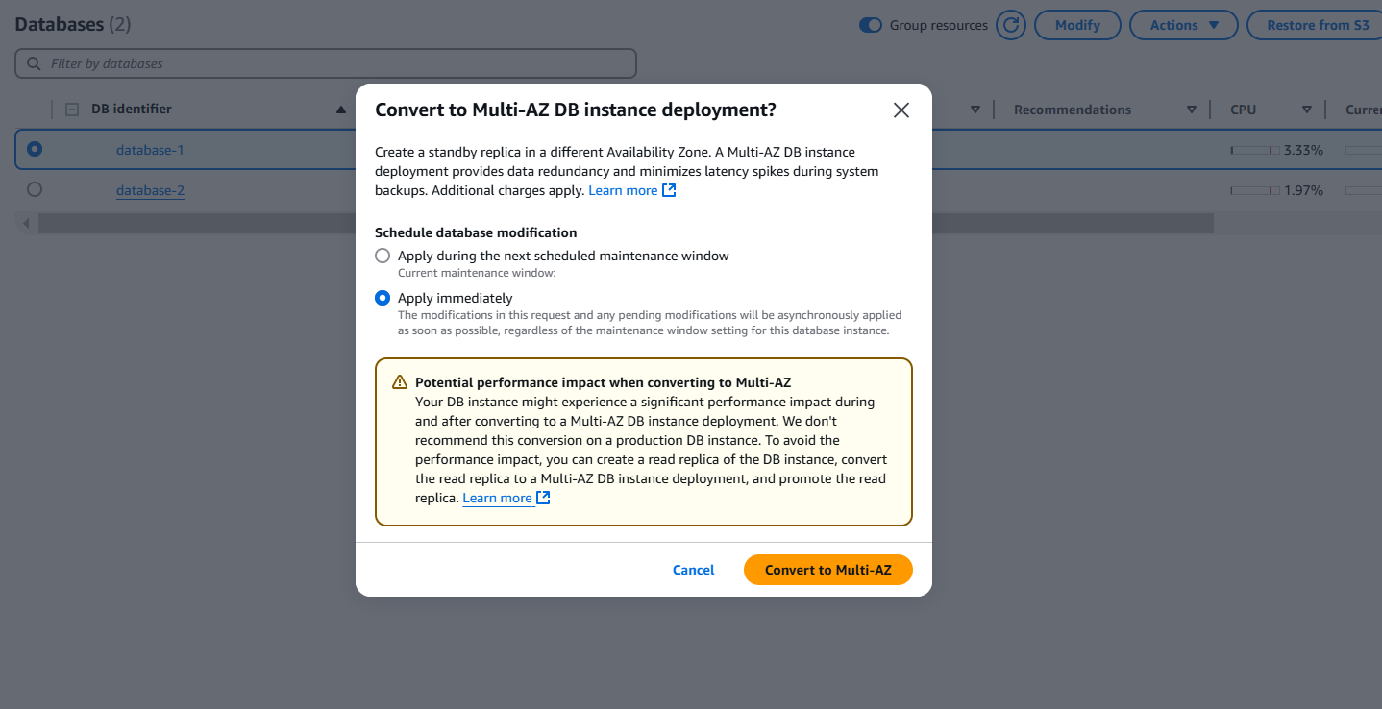

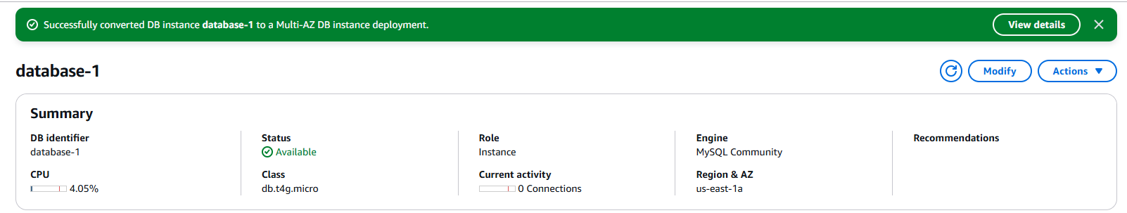

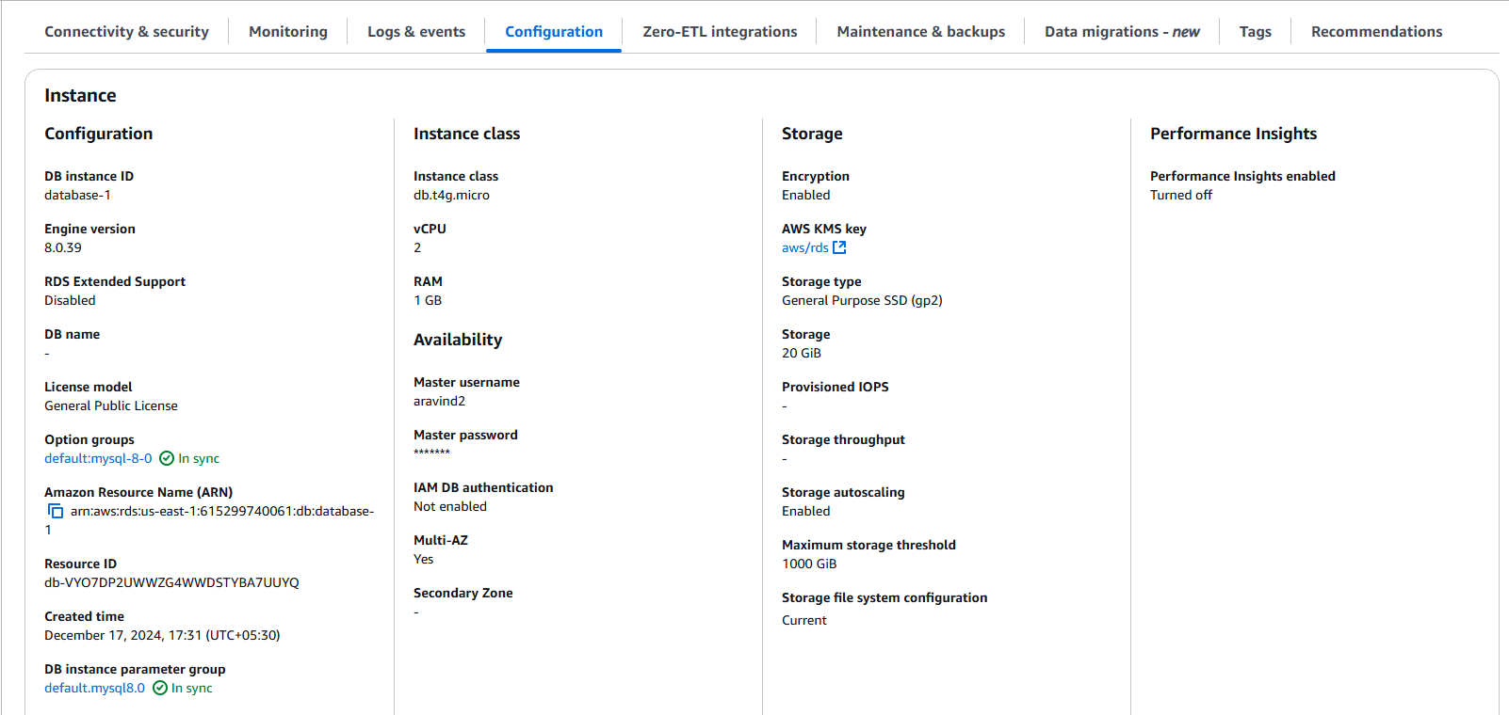

*Take Backup of db and restore the DB*

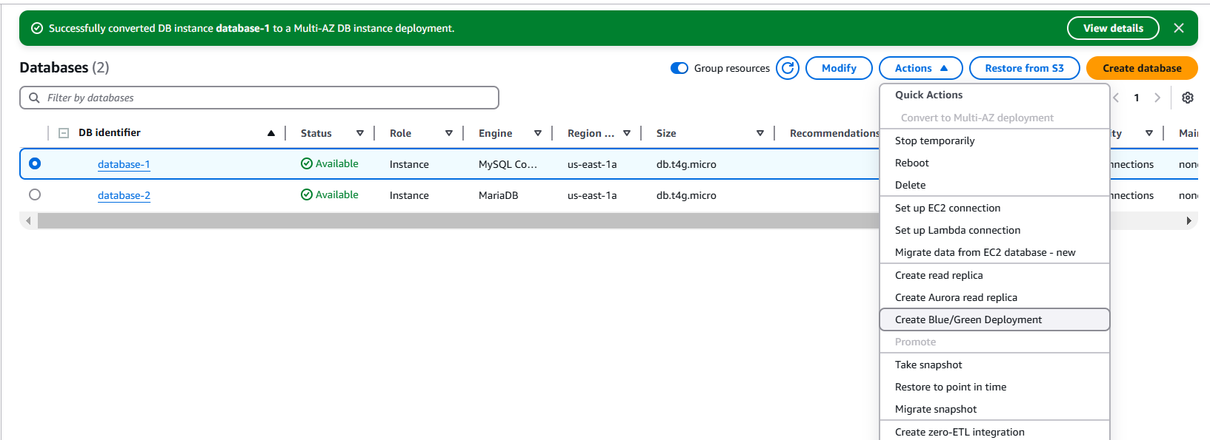

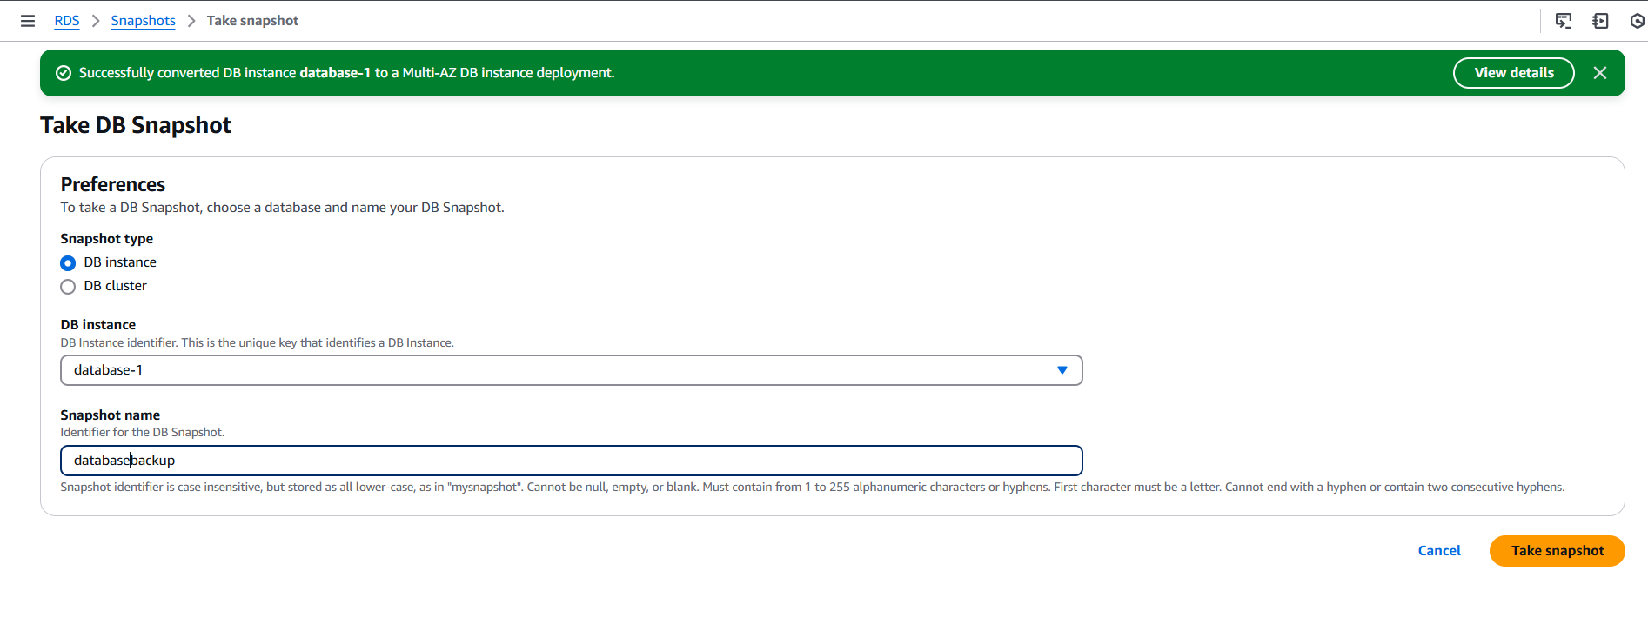

***Created one snapshot***

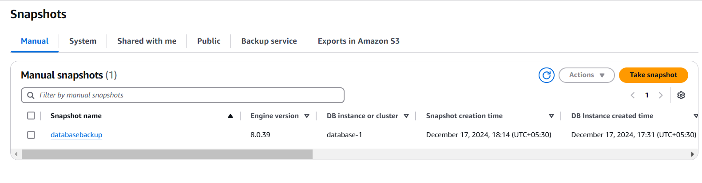

*Here,status is available*

*Now deleting the database1*

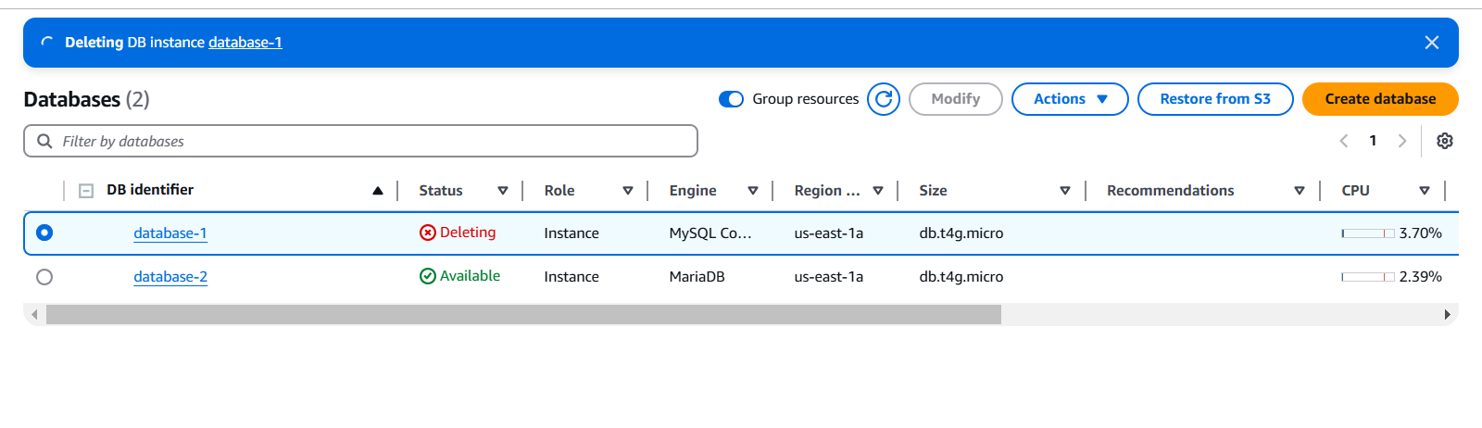

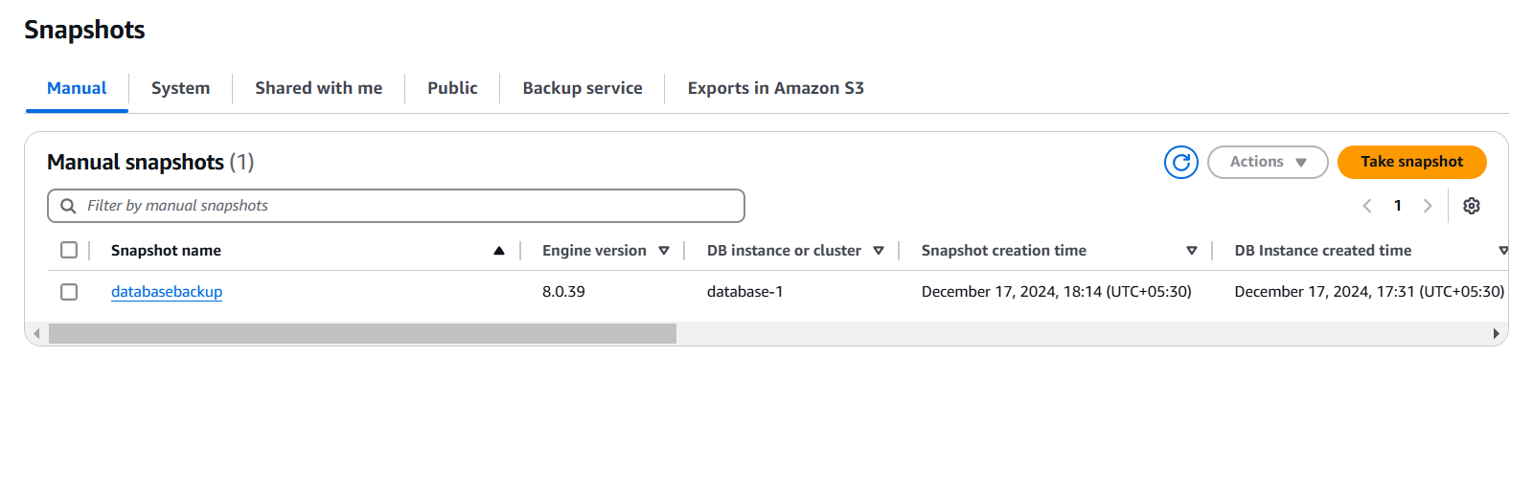

*Go to snapshots  
Select the database-backup  
Go to actions>restore db****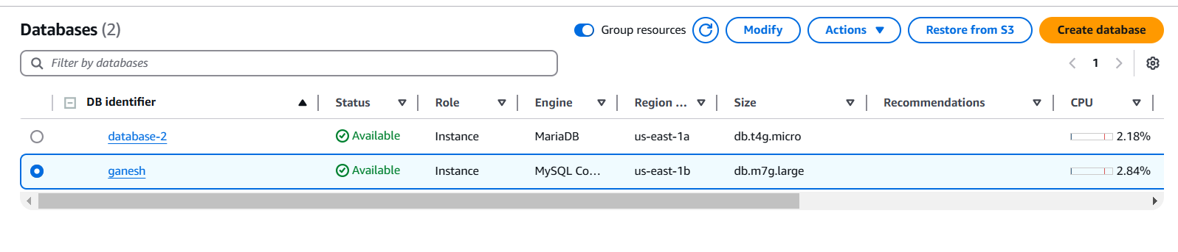***

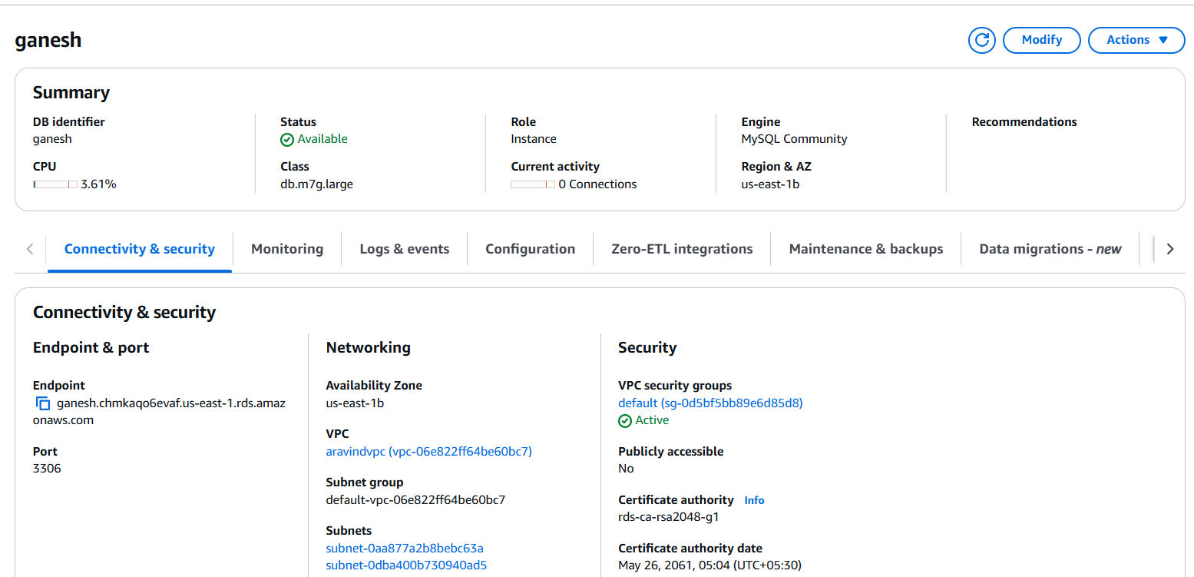

*Create ReadReplica*

